***Mahatma Gandhi Shikshan Mandal’s***

**Smt. Sharchchandrika Suresh Patil**

**Institute of Technology (Polytechnic), Chopda**



**A Project Report On**

**“Fast Food Restaurant Management”**

**Submitted By: -**

**1.Kumbhar Mayur Vasudeo.**

**Guided By: -**

**Prof. D. M Fegade**

**Department of Computer Engineering 2019-2020**

|  |
| --- |
| **Index** |

|  |  |  |
| --- | --- | --- |
| Chapter No | Title | Page No |
| 1. | **Introduction** | **3** |
| 2. | **Existing System**   * **Description** * **Proposed System** | **4** |
| 3. | **System Requirements**   * **Software Requirements** * **Language Requirements** * **Database Related Requirements** * **Hardware Requirements** | **6** |
| 4. | **Functional Specification**   * **Login Module** * **Menu Module** * **Order Module** * **Booking Module** | **8** |
| 5. | **System Design**   * **Data Flow Diagram** * **ER Diagram** | **10** |
| 6. | **Data Dictionary**   * **Vegetarian Menu** * **Non-vegetarian Menu** * **Dessert Menu** * **General Menu** * **Ordering** * **Booking** | **13** |
| 7. | **Implementation**   * **Screen Shots** | **15** |
| 8. | Conclusion   * Advantages * Limitations * Future work | 21 |

**Chapter 1**

**Introduction**

This project is about implementing a fast food restaurant management for users to search, order or even book tables in restaurant using an application. People sometimes just visit the application to see the menu card, price list and facilities. Our application helps a user to see the different kinds of menu categorized by the management of restaurant. The user can even order food items by selecting them by their own and even can see the billing side by side. An advantage of using my application is a user has security provided by asking him/her a username and password assigned to them when they came first int the restaurant every time they login to our application. When a user login successfully he/she is able to see the main page of application where the user can navigate according to its choice, can see menu showing different categories as vegetarian, non-vegetarian, desserts(ice-cream), drinks (tea, coffee, Coke etc.) by clicking on the required button on the page.

While seeing the menu the user has an option to order the food by clicking on the order menu and need to enter some basic information as name, mobile no.

The purpose of having a separate menu section is that a user can see the updates of menus and prices that may have been done in certain days he/she had no logged in. While ordering for the food item the user need to select the category of food and then food and quantity, he/she want and can press add button to move on to the next ordering item. When the user press adds button, the control is transferred to the text area where the dish with quantity, price and user details in a bill format is displayed. As soon as the user finish Ordering he/she can press bill button to generate total bill.

With the ordering facility it has a booking facility so that user can book the tables in advance so that they must not experience inconvenience while they come with the family and friend to enjoy. Booking is easy process the user just needs to enter basic information (name, mobile no, email and date for booking) so that the management may contact him/her to confirm booking and after filling details it just need to click on book button.

**Chapter 2**

**Existing System**

* **Description –**

Many restaurants around us are using manual methods to manage their day-today management which is time consuming, risky and costly. Time consuming because humans can’t work faster than machine also, they can’t work for continue 24 hours they need break so the to be done takes more time it should take. Costly because if we are using manual methods to do so we need an experienced and accurate person who knows how to manage all the things related to restaurant and hiring people involves spending money on them. Risky because as we said humans need break sometimes the people associated with it may get disturbed due to some non-professional or emotional reasons so they may make mistakes while managing tasks and this may lead to a huge loss to the restaurant.

Also, using manual methods has involvement of hand written document these documents require space to store and data may get lost due some natural (earthquakes, Floods, Cyclones) or manmade (blast, fire) disasters

And because of this there is a risk of loss of data. Also storing data in hand written files is not secure anyone can see them. Though people are using digital methods but they limited to calculating bills daily and accounting at the end of the month but to overcome these limitations we have proposed a software to manage some task of a restaurant.

Summarizing:

1. Risk of data loss.
2. Data is not secure.
3. Time consuming.
4. Costly.
5. Data is not permanent.

* **Proposed System –**

As we mentioned above the limitations of manual management. Here we are going to see about our “Fast Food Restaurant Management” software. Its advantages, why to use it etc. Using a software to manage all the task of restaurant is easy and efficient. Though it requires money to buy a software but it is one-time investment foe long future and also, we can develop it as per our comfort and requirements.

Using this software, we can allow user to see the menu and brows our software according to their choice. They can select their choice of food to order their no one to look back to them so they feel inconvenient. They can also book tables in advance so that they enjoy their quality time without worrying about the crowd. Such facilities attract customers because they are developed for them only.

The data of user is secure because they are assigned with username and passwords so that no one can see their details. All the orders and bookings are stored in database so that in future if we need any information, we can access it. There is separate menu page to see the menu which are categorized so that if in future if there is any change in menu list or prize user can check it out. Our project does not use any online service so we can use it at particular PC only.

**Chapter 3**

**Resources**

* **Software Resources**

1. Text pad – Text pad is the text editor of Microsoft Windows family of operating system. The software is easy to install and currently working in its eighth version. The software support java language to run the java programs.

It provides basic features so that we can type the easily: -

1. The ability to maintain block indents.
2. Automatic Code Indentation
3. Ability to call external programs like compilers.
4. Automatic integration with java JDK, if JDK is already on machine.
5. Operating System – No specific operating system because java is platform independent language.

* **Language Resources**

1. Advance Java - Advance java is having the concept of Java fundamentals. Advance java is used to developing the web-based application and enterprise application. Advance java differentiation such as in web, DCOM, or database.

Here we used some components of java as:

1. Swing Components
2. JDBC and ODBC Connection

* **Database Resources**

1. MS Access Database -Microsoft Access is a [database management system](https://en.wikipedia.org/wiki/Database_management_system) (DBMS) from [Microsoft](https://en.wikipedia.org/wiki/Microsoft) that combines the [relational](https://en.wikipedia.org/wiki/Relational_database) [Microsoft Jet Database Engine](https://en.wikipedia.org/wiki/Microsoft_Jet_Database_Engine) with a [graphical user interface](https://en.wikipedia.org/wiki/Graphical_user_interface) and software-development tools. It is a member of the [Microsoft Office](https://en.wikipedia.org/wiki/Microsoft_Office) suite of applications, included in the Professional and higher editions or sold separately.
2. **JDBC -** The database connectivity is referred to the ability of Java programs to carry out CRUD, i.e. create, read, update and delete operations on the data persisted in a relational database. Java database connectivity is a very popular way of achieving database connectivity. There are many JDBC driver but here in our project we used Type 1 Driver.

* **Hardware Resources**

1. **Processor –** Core i3 or core i5 having at least 4GB RAM.
2. **Disk Space –** 100 MB or more

**Chapter 4**

**Functional Specification**

The restaurant management system has many modules to make the software more efficient and user friendly. The modules make the database management easier. The modules are made according to their working or requirements.

* **Login Module –**

Login module consist of authenticating user as the user is valid or not.

The use is assigned with a particular username and password so that the user has its security in its own hands. The login module allows the authenticated user to enter into the software.

* **Menu Module-**

Menu module consist of various categories of menus as Vegetarian, Non-Vegetarian, Desserts, Drinks etc. Categorizing the food items helps the user to visit the menus that he/she wanted to see and visit not the unnecessary one. Menu module helps us to organize our menu item so that when updates are made, we can easily see them. The user just has to click on the menu buttons to see the menu with its price list.

* **Order Module-**

Restaurant management not only include showing menus digitally. The software is useless if it does not provide any facility which saves the human effort. In order module the user again has to select the food item by category only and here he/she have to provide his/her name, contact no so that it is easy to store the records in the order database. In order module while a user is ordering he can order multiple orders by just adding it to bill and when finish ordering he/she has to press bill button to generate button. As soon as the user press the bill button a full bill format with name, date, time, contact no and total amount is displayed.

* **Booking Module –**

In a restaurant people may want to have a facility of booking table for next time they visit the restaurant so that they may not feel inconvenience. Pre booking in a famous restaurant is always a preferable choice of customers. So, our software also provides booking facility here the user can book a table by just giving some information as Name, contact no, Email address, no of people (booking for how many no of people), and date for the people.

As soon as the user press book button its booking is shown on right hand side.

**Chapter 5**

**System Design**

* **Data Flow Diagram –**

**DFD level 0**

Fast Food Restaurant System

Booking Module

Order Module

Login Module

Menu Module

Login details

Authentication Provided

Order Request

Request for menus

Menu table provided

Booking request

Booking status

Order Status

**DFD level 1 – Menu Model**

**Menu** **Module**

**Vegetarian** **Menu**

**Non**-**Vegetarian** **Menu**

**Dessert** **Menu**

**General** **Drinks**

**Process Request to see Veg Menu**

**Process Request to see General Menu**

**Process Request to see Dessert Menu**

**Process Request to see Non- Menu**

**DFD level 1- Order Module**

**Check Order for Veg Menu**

**Order Module**

**Vegetarian Food**

**Non-Veg Food**

**Dessert**

**General Drinks**

**Bill** **Generation**

**Check Order for Non-Veg Menu**

**Check Order for Dessert Menu**

**Check Order for General Menu**

**DFD level 1- Booking Module**

**Process the Booking by Storing user provided data**

**Booking** **Module**

**Booking** **Database**

* **ER Diagram**

**Order**

**Login**

**Username**

**See**

**Menu**

**Veg Menu**

**Non-Veg Menu**

**Dessert Menu**

**General Menu**

**Book**

**Table**

**BookingID**

**Customer Name**

**Contact**

**Date/Time**

**For No of People**

**Food**

**Order’s**

**Category**

**Price**

**Food Name**

**FoodID**

**OrderID**

**Amount**

**Date/Time**

**Contact**

**Has**

**Bill Date**

**Bill Amount**

**BillID**

**Password**

**User**

**Has**

**Store’s**

**Name**

**Bill**

**Chapter 6**

**Data Dictionary**

1. **Vegetarian Menu Table**

|  |  |  |
| --- | --- | --- |
| Field Name | Data Type | Size |
| VegID | AutoNumber |  |
| VegName | Text | 255 |
| VegPrice | Number | Long Integer |

1. **Non-Vegetarian Menu Table**

|  |  |  |
| --- | --- | --- |
| Field Name | Data Type | Size |
| NonVegID | AutoNumber |  |
| NonVegName | Text | 255 |
| NonVegPrice | Number | Long Integer |

1. **Dessert Menu Table**

|  |  |  |
| --- | --- | --- |
| Field Name | Data Type | Size |
| DessertID | AutoNumber |  |
| DessertName | Text | 255 |
| DessertPrice | Number | Long Integer |

1. **General Drinks Menu Table**

|  |  |  |
| --- | --- | --- |
| Field Name | Data Type | Size |
| DessertID | AutoNumber |  |
| DessertName | Text | 255 |
| DessertPrice | Number | Long Integer |

1. **Orders Table**

|  |  |  |
| --- | --- | --- |
| Field Name | Data Type | Size |
| OrderID | AutoNumber |  |
| OrderName | Text | 255 |
| OrderDate | Date/Time |  |
| OrderBill | Number | Long Integer |
| OrderMobile | Text | 255 |

1. **Booking Table**

|  |  |  |
| --- | --- | --- |
| Field Name | Data Type | Size |
| BookingID | AutoNumber |  |
| BookingName | Text | 255 |
| BookingMobile | Text | 255 |
| BookingDate | Date/Time |  |
| BookingEmail | Text | 255 |
| BookingNoOfPeople | Number | Long Integer |

**Chapter 7**

**Implementation**

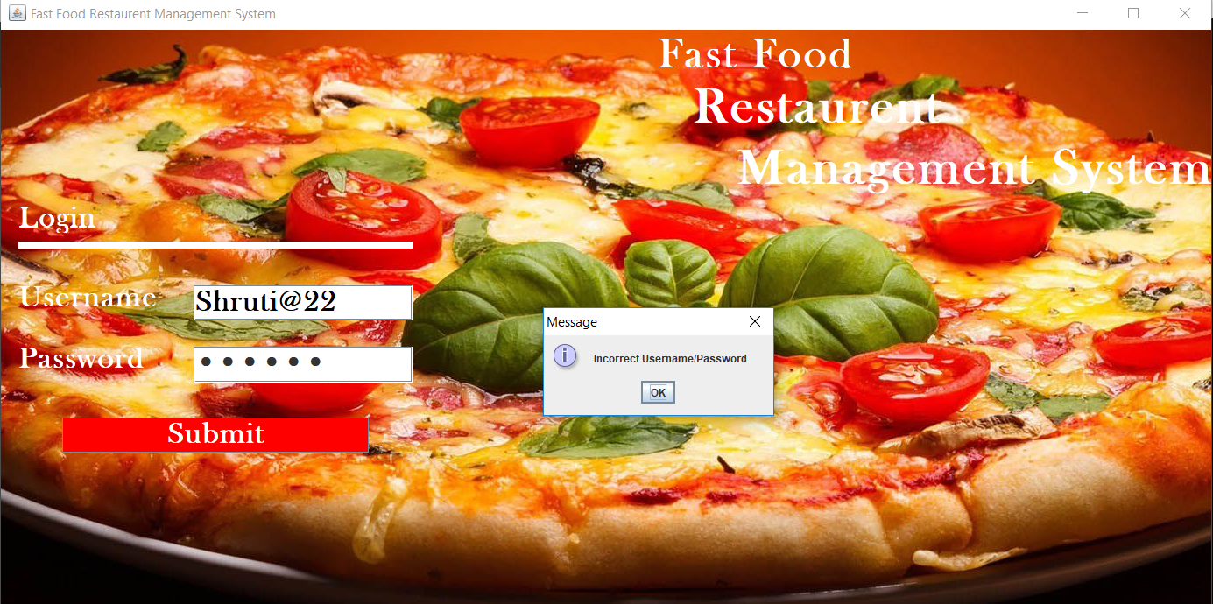

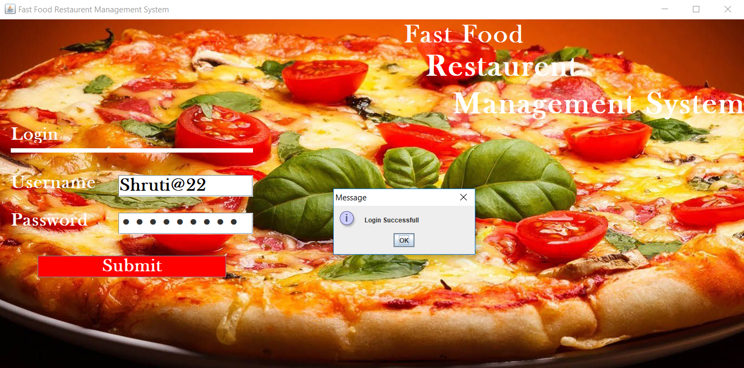

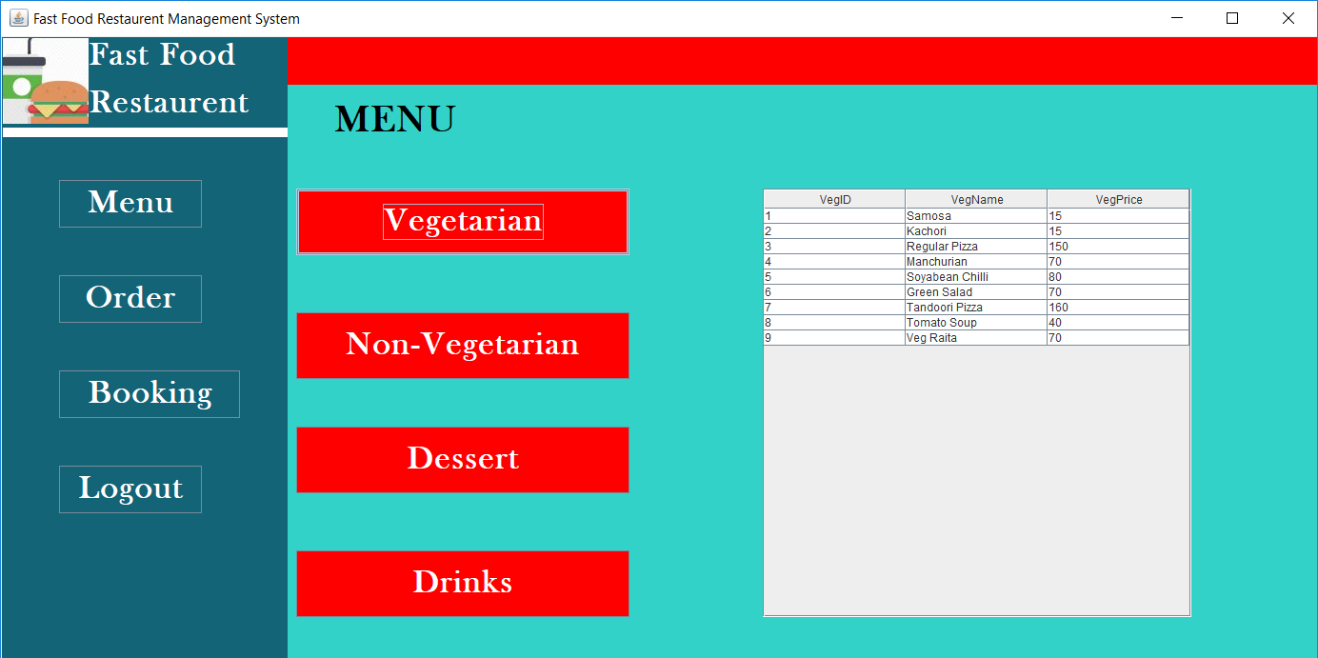

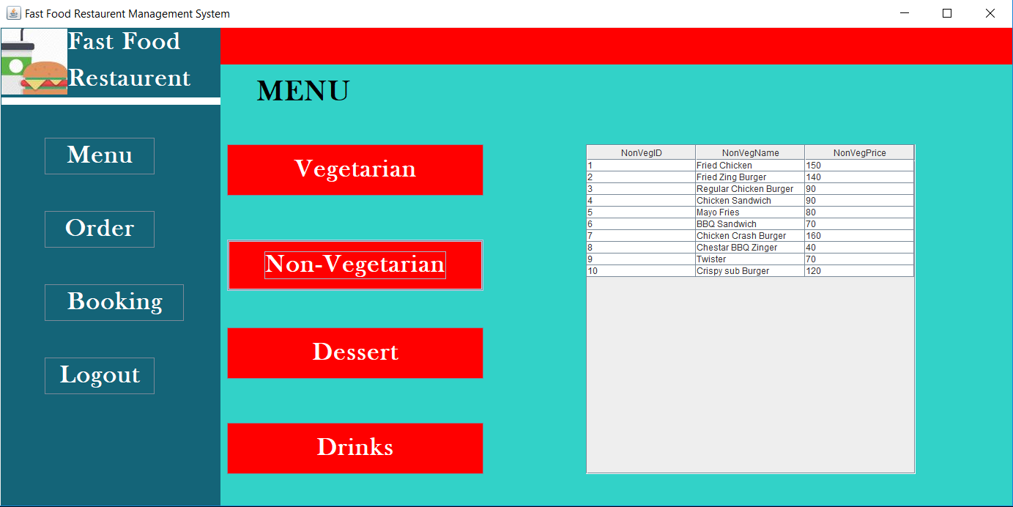

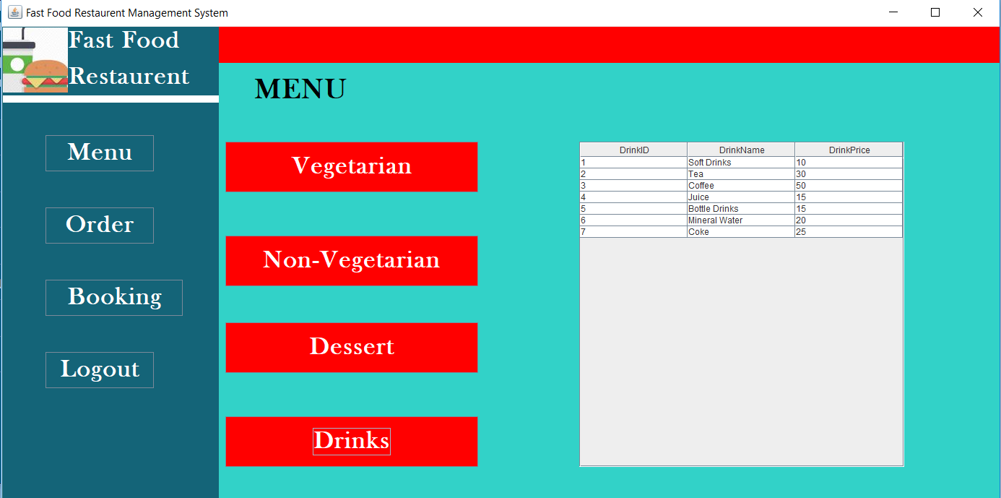

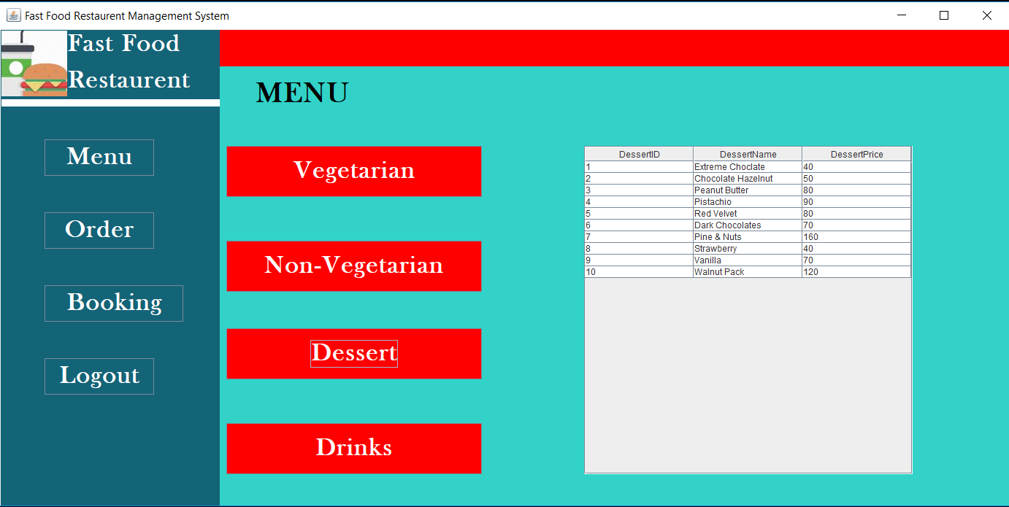

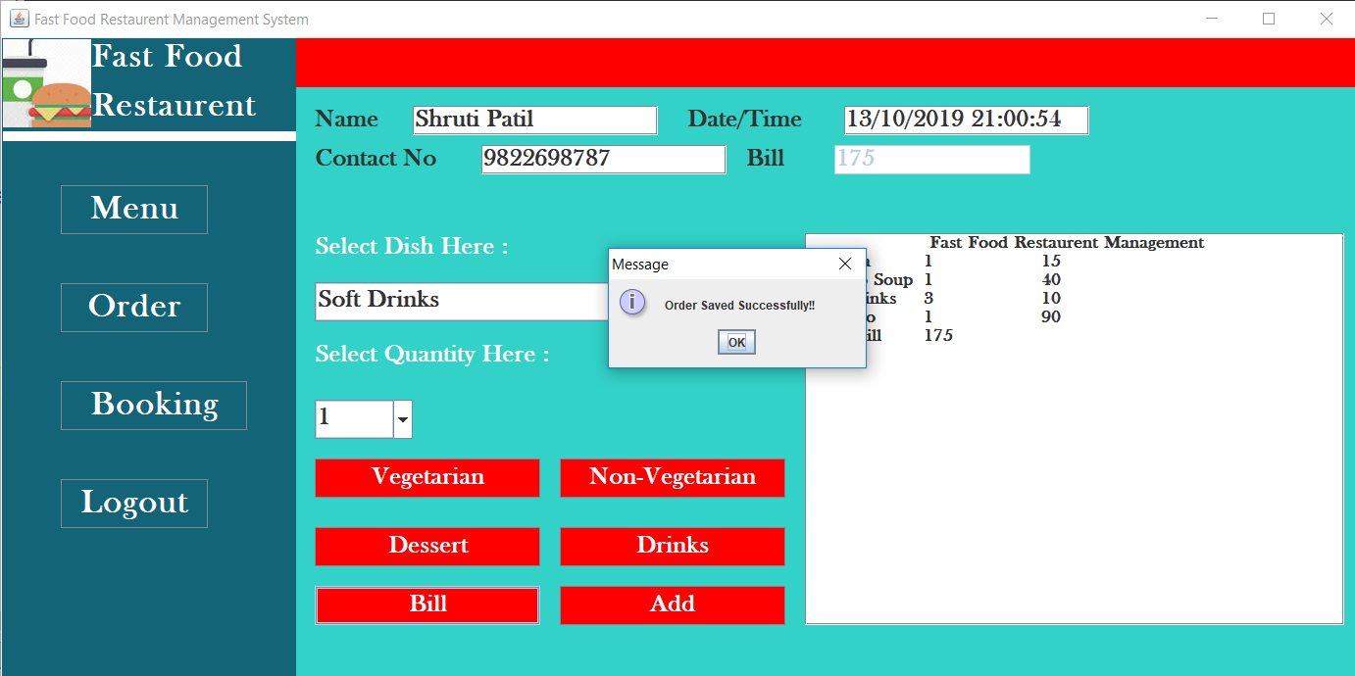

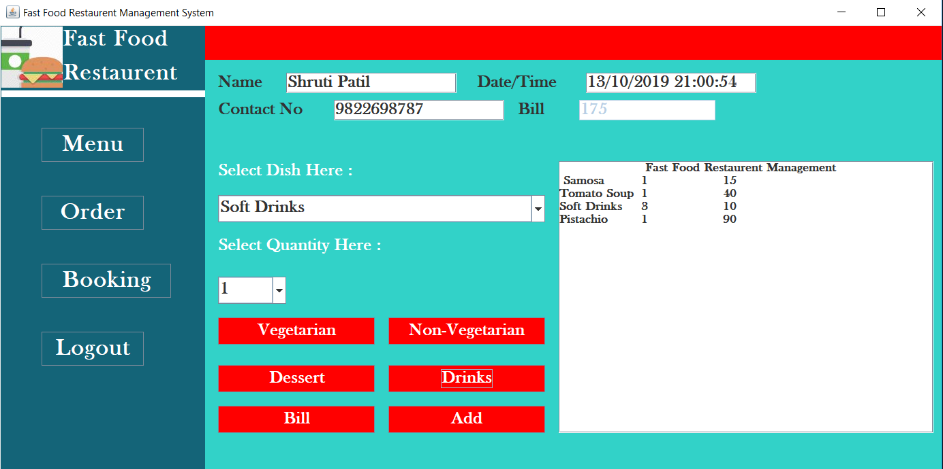

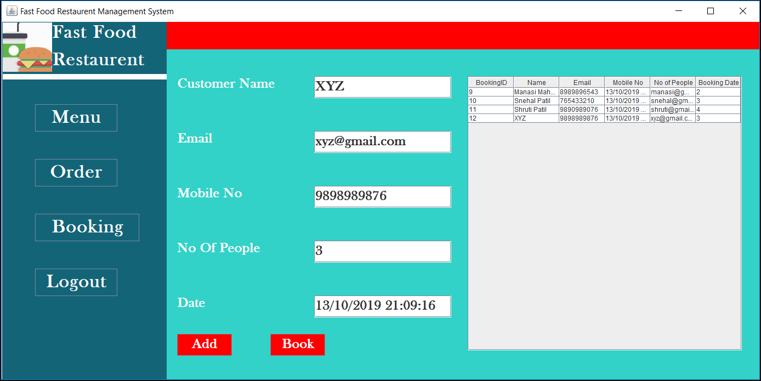

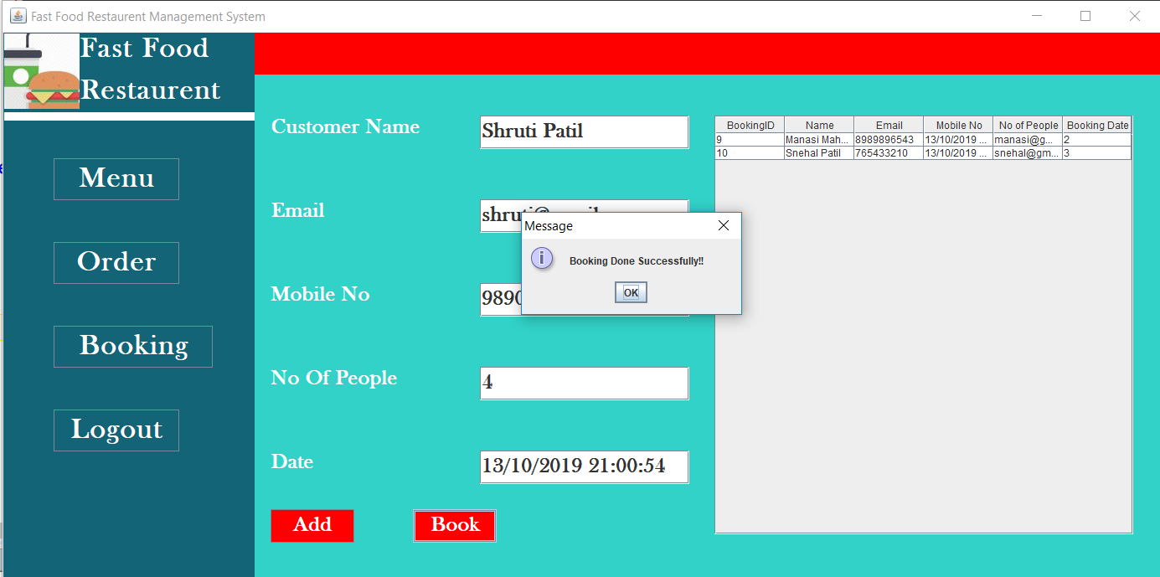

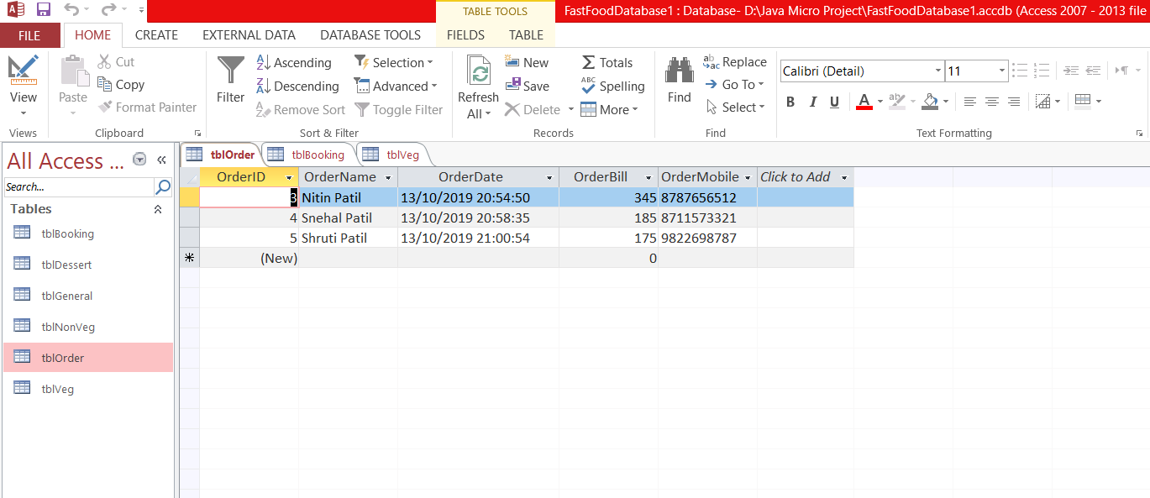

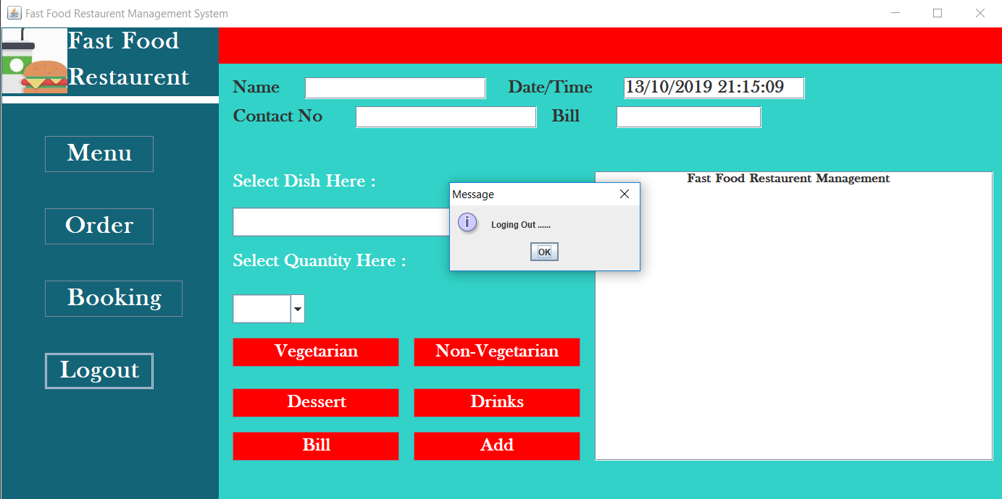

**Chapter 8**

**Conclusion**

* **Advantages –**

1. Using a software makes the work easy and efficient than manually handling all the tasks.
2. There is no risk of data loss as all the data is stored in database permanently and can be viewed on time.
3. The system reduces manual work and expenses on them.
4. It also gives a status to the restaurant in the market.
5. All the orders and visited customer details as well as the booking data is stored in the database.
6. It also keeps record of food items like type, price etc.

* **Limitations –**

1. The system is only limited to a particular system it is not serving online.
2. The data is stored in a particular PC not on server.
3. User won’t be able to change the skin or functionality of system.
4. It does not store any staff related details.
5. It does not provide any expenses related records.

* **Future Work –**

1. User Interface can be change as per the user requirement so it attracts a greater number of customers.
2. The system can be made to serve online so that people can access it from anywhere.
3. The database can be on server to store data centrally.
4. Payment options can be added.
5. GPS tracking can be added if the system is made to run on mobile phone.